**Supporting Document**

**Web Map:**

**Wireframe:**

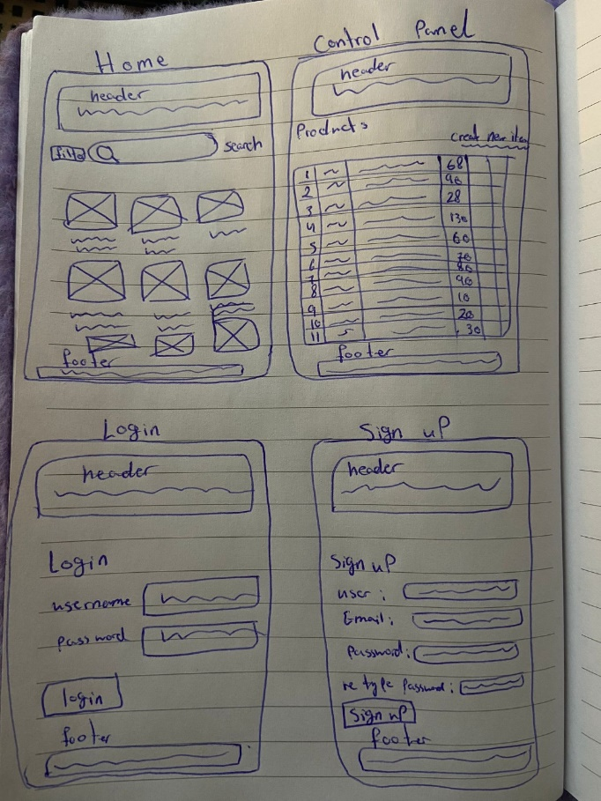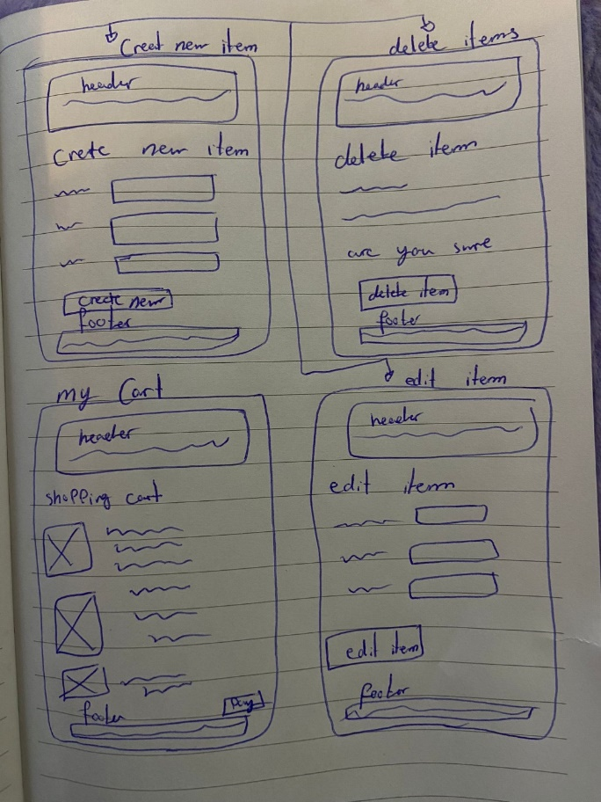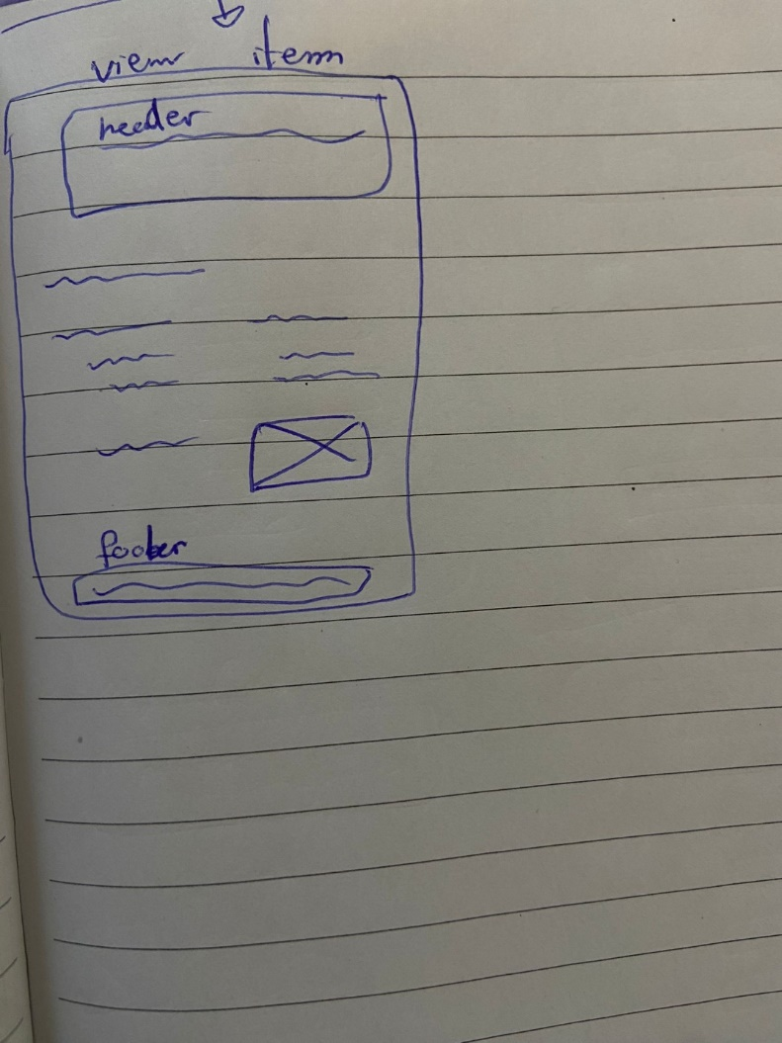

**Instruction Guide:**

1. **File Placement:**
   * Place the "assignment" file in the "Xamp -> htdocs" directory.
2. **Database Connection:**
   * Connect to XAMPP.
   * Import "Items.sql" into the database.
   * Import "User.sql" after importing "Items.sql".
   * Note: Ensure "Items.sql" is imported first as "User.sql" relies on it.
3. **Database Setup:**
   * "Items.sql" creates the "onlineshopping" database, and "User.sql" utilizes it.
4. **Accessing the Webpage:**
   * Proceed to our webpage using the following URL: <http://localhost/assignment/index.php>

**Description of database:**

**Items.sql** **–** it serves as a repository for item-related information. It functions as a back-end database where data modifications such as insertion updates or deletions are managed.

**User.sql –** It serves as a back-end database repository for storing user data. When a user signs up, their information is stored in back-end repository. During login process, the program retrieve data from user.sql to validate the user.